Project-Phase 1
  - Deadline: Day 26/07/2026 @ 23:59
[Total Mark is 5]

Computer Networks
DS360

Instructions:
- You must submit two separate copies (one Word file and one PDF file) using the Assignment Template on Blackboard via the allocated folder. These files must not be in compressed format.
- It is your responsibility to check and make sure that you have uploaded both the correct files.
- Zero mark will be given if you try to bypass the SafeAssign (e.g., misspell words, remove spaces between words, hide characters, use different character sets, convert text into image or languages other than English or any kind of manipulation).
- Email submission will not be accepted.
- You are advised to make your work clear and well-presented. This includes filling your information on the cover page.
- You must use this template, failing which will result in zero mark.
- You MUST show all your work, and text must not be converted into an image, unless specified otherwise by the question.
- Late submission will result in ZERO mark.
- The work should be your own, copying from students or other resources will result in ZERO mark.
- Use Times New Roman font for all your answers.
Student Details: CRN:
Name:  Name:  Name: |  | ID:  ID:  ID:

Project Instruction
Project Objective:
Design, configure, and test a network setup in Packet Tracer to successfully transmit data packets between devices in different LANs across two separate WANs (WAN 1 and WAN 2).
Group Details
- Group Size = Maximum of 3 Members.
- One group member (group leader/coordinator) must submit the project report on blackboard. Marks will be given based on your submission and quality of the contents.
Project Report
- The project is divided into two phases:
  - Phase 1 (Mid project Progress Report)
  - Phase 2 (Final project Report)
- This report is for Phase 1. In this report, you should complete all the requirements for Phase 1 only.
- Each Report will be evaluated according to the marking criteria

Project Description (Common to Phase 1 and Phase 2)
Learning Outcome(s):
Demonstrate protocol configuration, network-addressing schemes and analyze packet transmission for the Local and Wide Area Networks.

A university operates two campuses: a Main Campus and a Branch Campus. Each campus network is treated as a separate WAN site. Your task is to design and configure, in Cisco Packet Tracer, a network that successfully transmits data packets from a device in any LAN of WAN 1 (Main Campus) to a device in any LAN of WAN 2 (Branch Campus). Each WAN contains 2 LANs, and each LAN has 3 end devices.

Network Design Requirements:
- WAN 1 (Main Campus):
  - Contains LAN 1 (Computer Lab) and LAN 2 (Admin Office).
  - Each LAN has 3 devices (PCs or laptops) connected through a switch.
  - Assign private IP addresses to the devices in each LAN (e.g., use 172.16.10.0/24 for LAN 1 and 172.16.20.0/24 for LAN 2).
  - Connect each LAN to a router (Router 1).
- WAN 2 (Branch Campus):
  - Contains LAN 3 (Library) and LAN 4 (Faculty Office).
  - Each LAN has 3 devices (PCs or laptops) connected through a switch.
  - Assign private IP addresses to the devices in each LAN (e.g., use 172.16.30.0/24 for LAN 3 and 172.16.40.0/24 for LAN 4).
  - Connect each LAN to a router (Router 2).
- WAN Connection:
  - Connect Router 1 and Router 2 using a serial link to simulate a WAN connection.
  - Assign IP addresses to the serial interfaces (e.g., 10.10.10.1/30 for Router 1 and 10.10.10.2/30 for Router 2).

Configuration Details:
- Assign IP Addresses:
  - Configure IP addresses, subnet masks, and default gateways for all devices in each LAN. Example:
    - LAN 1: 172.16.10.0/24, Default Gateway: 172.16.10.1 (Router 1's interface).
    - LAN 2: 172.16.20.0/24, Default Gateway: 172.16.20.1 (Router 1's interface).
    - LAN 3: 172.16.30.0/24, Default Gateway: 172.16.30.1 (Router 2's interface).
    - LAN 4: 172.16.40.0/24, Default Gateway: 172.16.40.1 (Router 2's interface).
- Router Configuration:
  - Configure IP addresses on the LAN and WAN interfaces of both routers. Example:
    - Router 1:
      - LAN 1 Interface: 172.16.10.1/24
      - LAN 2 Interface: 172.16.20.1/24
      - WAN Interface (Serial): 10.10.10.1/30
    - Router 2:
      - LAN 3 Interface: 172.16.30.1/24
      - LAN 4 Interface: 172.16.40.1/24
      - WAN Interface (Serial): 10.10.10.2/30
- Enable Routing:
  - Configure static routes or a dynamic routing protocol (e.g., RIP) on both routers to ensure communication between WAN 1 and WAN 2.

Phase 1 Requirements
5 Marks
Students are required to submit a short mid progress report, which must include the following:
- Work completed this period (2 marks): This includes the installation of Cisco Packet Tracer, and a study of Packet Tracer for creating nodes, using different types of links (copper straight-through, copper cross-over, serial DCE/DTE), and assigning IP addresses.
  - Note: You must show a screenshot of the installation of Packet Tracer (with your system visible, e.g., date/time or username). (1 mark)
  - Give a description of the objectives and advantages of using Packet Tracer for this project. (1 mark)
- One key decision made during this period (1 mark): For example, your choice of IP addressing scheme, choice of routing method to study, or division of work among group members. Explain briefly why the decision was made.
- One problem encountered (1 mark): Describe one genuine problem faced so far (technical or organizational) and its current status (resolved / in progress).
- Plan for the next period (0.5 mark): Briefly list the tasks you plan to complete before the final submission (e.g., building the topology, configuring routers, testing with ping).
- Each group member's input/participation (0.5 mark): State each member's name and their specific contribution during this period.

Version History / Commit Log Requirements (Common to Both Reports)
Students must document and submit their project history/timestamps using a live, editable link:
- Written report: Submit a shared Google Doc or Word Online link (sharing set to "Anyone with the link can view") along with your final PDF report. The link must show the progress of the students' work with timestamps/screenshots.
- Code/data/configuration files: Submit Packet Tracer files (.pkt) and any configuration scripts via a GitHub or GitLab repository link (the coordinator may choose a repository suitable for the course). The repository must show a commit history reflecting incremental progress. Commit regularly (at minimum once per week), with clear, descriptive commit messages.
A separate section in the report must be added and named "Project Artifacts" to include all links, for example:
  - Live report document (with edit history): [link]
  - GitHub/GitLab repository (with commit history): [link]
  - Packet Tracer project file (.pkt): [link or attached]
What NOT to do: Students must not write their report elsewhere and paste the final version in at the last minute. They also must not make a single commit containing the entire project. Both are treated as red flags regardless of the quality of the final work.

Important Notes
- AI use: Students may use AI tools (ChatGPT, Claude, Copilot, Gemini, etc.) only for brainstorming approaches, debugging small errors, or proofreading text. AI must not be used to generate analysis, write configuration logic, or produce substantial portions of the report or project files. Any permitted AI use must be disclosed in the Reflection section. Undisclosed AI use, or AI use beyond this scope (disclosed or not), will result in a zero grade for the entire project.
- Any submission lacking a valid, inspectable version/commit history, or showing evidence of AI generation or plagiarism, will receive a zero grade for the entire project.
- Failure to submit the mid progress report as required, or submission of reports found to be fabricated, copied, or AI-generated, will result in a zero grade for the entire project.
- The mid progress report should be concise including screenshots.
- The same shared document link and repository submitted in Phase 1 must continue to be used for Phase 2, so that the full project history is visible in one place.

Phase 1 Requirements
5 Marks
Students are required to submit a short mid progress report, which must include the following:
Work completed this period (2 marks): This includes the installation of Cisco Packet Tracer, and a study of Packet Tracer for creating nodes, using different types of links (copper straight-through, copper cross-over, serial DCE/DTE), and assigning IP addresses.
  - Note: You must show a screenshot of the installation of Packet Tracer (with your system visible, e.g., date/time or username). (1 mark)
  - Give a description of the objectives and advantages of using Packet Tracer for this project. (1 mark)
One key decision made during this period (1 mark): For example, your choice of IP addressing scheme, choice of routing method to study, or division of work among group members. Explain briefly why the decision was made.
One problem encountered (1 mark): Describe one genuine problem faced so far (technical or organizational) and its current status (resolved / in progress).
Plan for the next period (0.5 mark): Briefly list the tasks you plan to complete before the final submission (e.g., building the topology, configuring routers, testing with ping).
Each group member's input/participation (0.5 mark): State each member's name and their specific contribution during this period.

Answer:
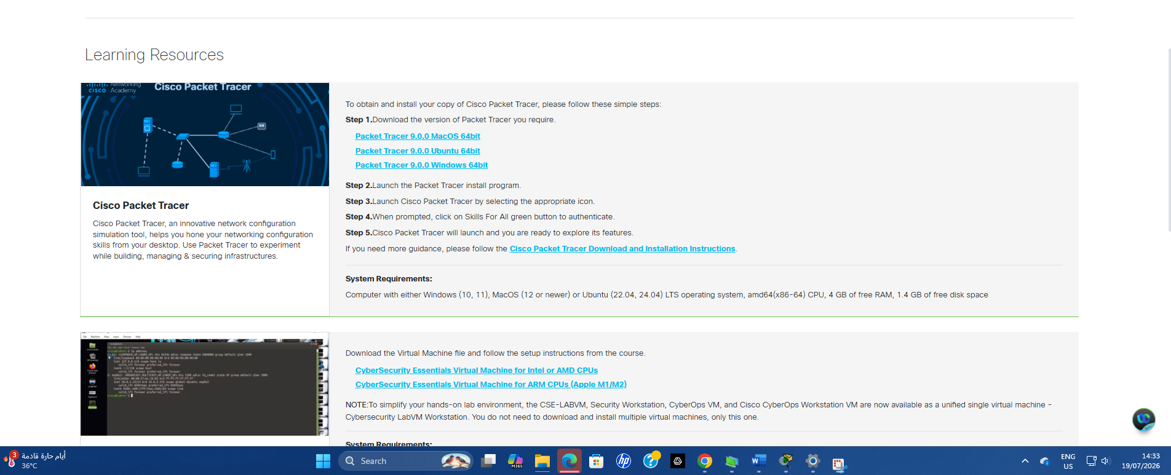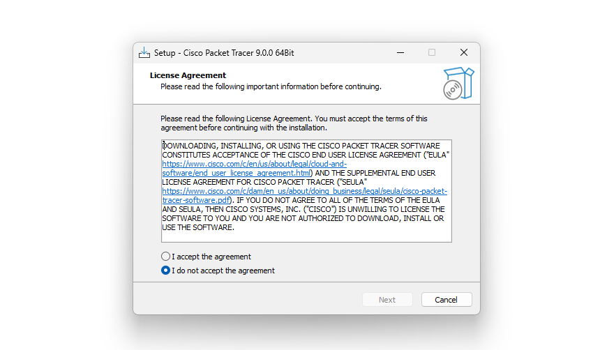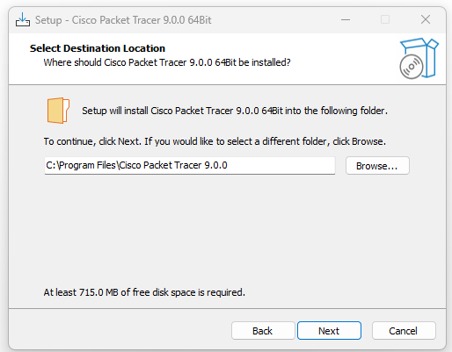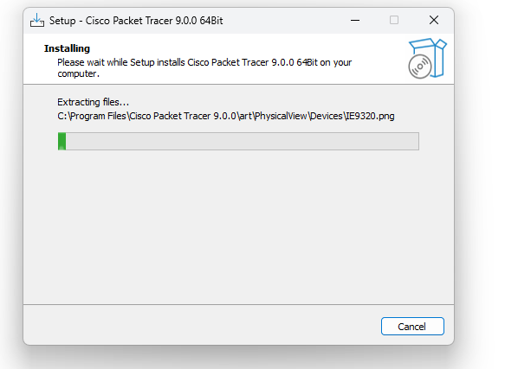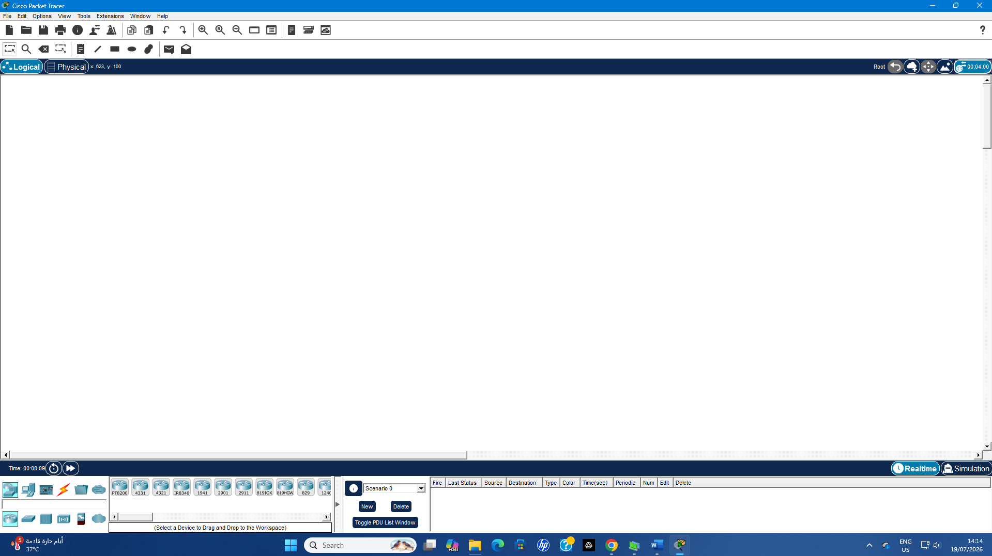

Work Completed During This Period
Cisco Packet Tracer had been installed and it was at that time tested on the computer. The introduced the use of the Packet Tracer interface, selecting devices area and workspace and configuration windows for all project team members. That meant working with Basic Networking Devices, such as Routers, Switches and PCs. Others were the Copper Straight-Through, Copper Cross-Over and Serial DCE/DTE cables. The team also investigated on how to configure IP addresses, subnet masks and default gateways on end-devices.
Goals and Advantages of Cisco Packet Tracer
Cisco Packet Tracer is a simulation program developed by Cisco Systems that allows students to experiment with network behaviour and test out networks using virtual hardware. Do the project by connecting two campus networks with some point to WAN connection and make sure that all LANs talk to each other. Packet tracer is used for this purpose.
NET — Benefits of Using Packet Tracer in Networking Development Offers working with routers, switches and end devices, which means enable you to configure IP addressing connect various devices using different cable type use Ping command on them verify network connectivity. It will allow you to identify configuration mistakes before bringing the network online. In addition, Packet Tracer is user-friendly, and time- & cost-effective and also provides a safe environment for learning networking knowledge and troubleshooting configuration issues.
A major decision to be did in between this period
Static Routing: Here it was decided to interconnect both of them campus networks using Static Router instead dynamic routing protocols. Static routing will help to solve the problem of what route will be used for sending traffic between two WAN sites, when only 2 routers and small size LAN We need in compliance with your project!
This option was chosen because static routing configuration is simple, it needs less system resources and it allows full control of routes used for routing. This will also help the team in understanding routers that shift packets between two different networks before implementing more advanced routing techniques.
One Problem Encountered
We could not distinguish the two types from among those that we can click on when clicking them in Cisco Packet Tracer, especially Copper Straight-Through, Copper Cross-Over and Serial DCE/DTE or whatever simulator you're using to setup. This ensured that some devices would be disconnected before the next retries in the first place.
Reading through the documentation and testing a few connection scenarios on Packet Tracer fixed this. The team neatly attached the devices as required after associating a purpose to each cable, completing their project.
Plan for the Next Period
In the second part of this project, I will finalize network topology in Cisco Packet Tracer and add all routers, switches and end devices. Assign the necessary IP and default-gateway to each LAN also add the serial WAN link between both routers. You will then setup static routes that permit the traffic to travel from one campus all the way to the other. At last, you will do ping test from device to devices then check Packet Tracer file as well project report one last hit and submit It.
.
Each Group Member's Input/Participation
Group Member | Contribution
Member 1 | Installed Cisco Packet Tracer, explored the software interface, and prepared the initial report.
Member 2 | Studied the network topology requirements, IP addressing scheme, and cable types used in the project.
Member 3 | Researched routing methods, reviewed the project requirements, and helped organize the project plan and documentation.

Topology
